

VERTICAL DIFFUSION PM PROCEDURE (Poly)
PM Type: BPM – Big PM Prepared by:
Machine: LP-Poly Robin 羅彬森
PM Frequency: 18μ±1大PM S200 FURNACE
Date: March 2017

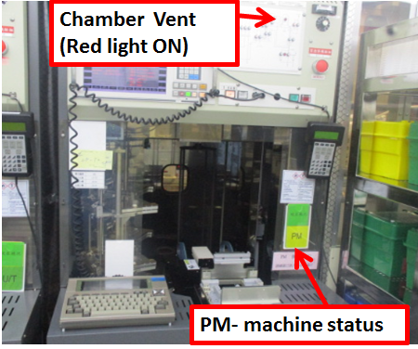 |  |  |  | 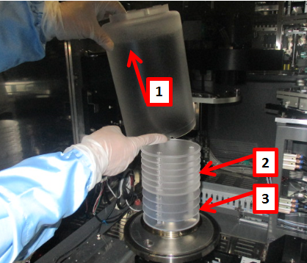
1. Confirm if machine ready for PM, check if machine already vent |  | 2. Get controller from front of machine, and connect to back terminal on lower right side. |  | 3. Remove pedestal cover +7fins+5fins and bring to parts cleaning area

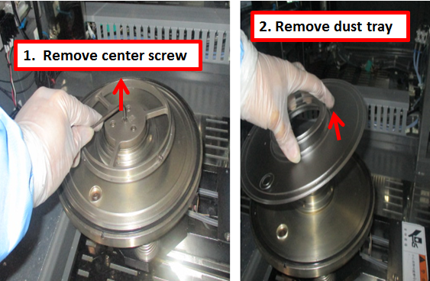 |  |  |  | 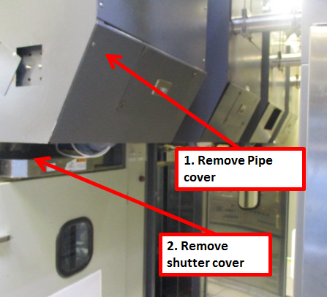
4. Remove dust tray |  | 5. Remove boat |  | 6. Remove back machine cover, and remove shutter cover

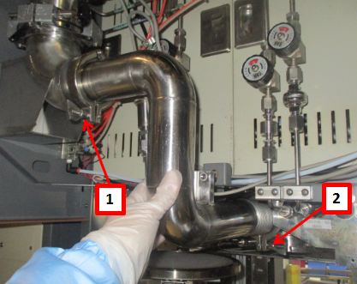 |  | 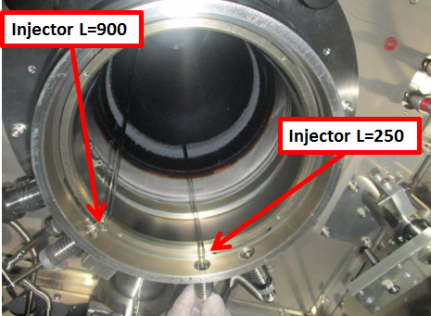 |  | 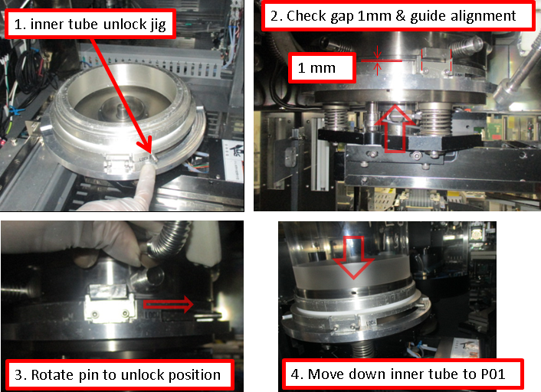
7. Remove pipe, and shutter |  | 8. Remove Injector L=900 + L=250 |  | 9. Place inner tube jig in boat lifter and move up to get inner tube

Doc. #: 2017-CRP-002 rev.00 Page 1 of 4

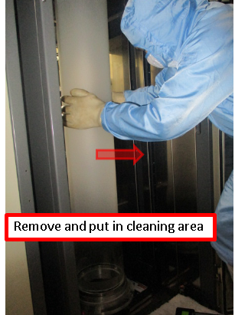 | 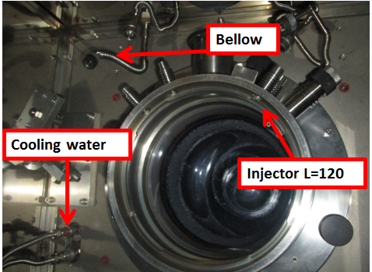 |  |  | 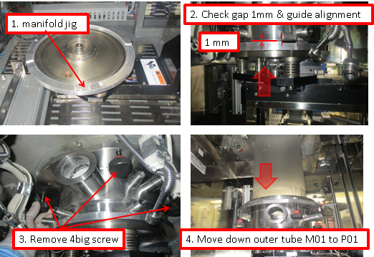
10. Using safety gloves remove inner tube and bring to cleaning area using push cart. |  | 11. remove L-120 injector and bellow connection and detach manifold cooling water fittings |  | 12. bring down manifold & outer tube using manifold jig

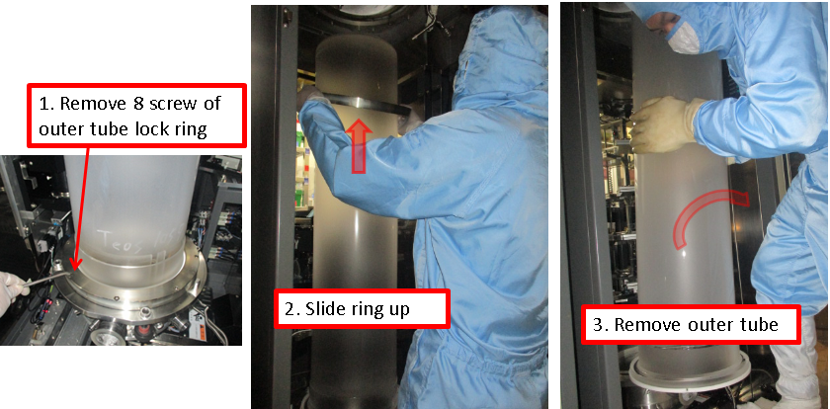 |  | 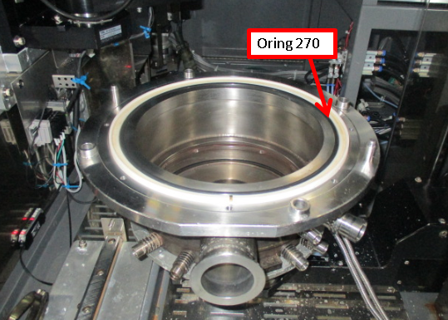 |  | 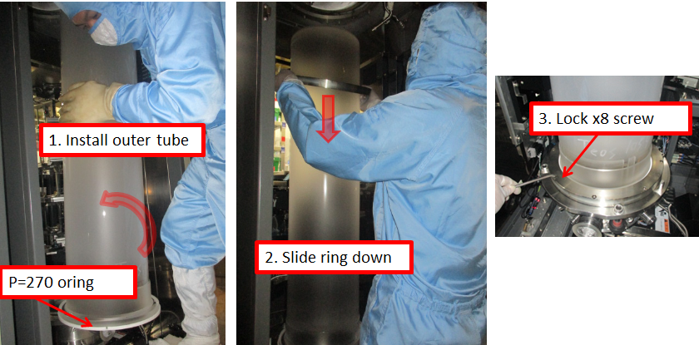
13. Using safety gloves remove inner tube and bring to cleaning area using push cart. |  | 14. Clean and reuse old manifold. Install new Oring |  | 15. Install new manifold and outer tube. Use P270 oring

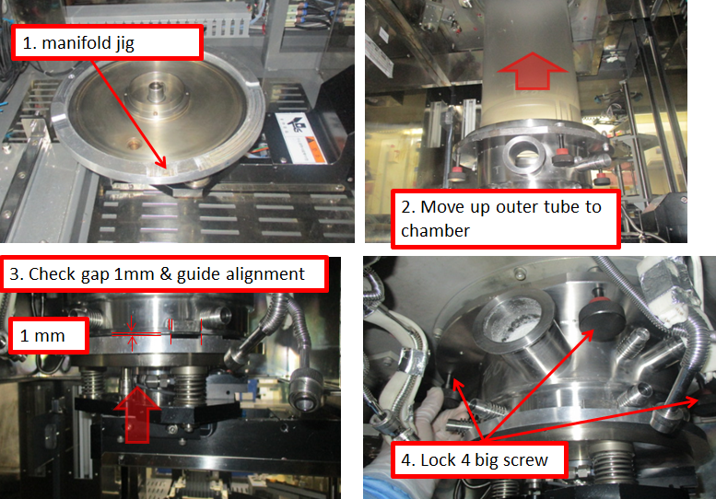 |  | 14. Install new manifold and outer tube. Use P270 oring |  | 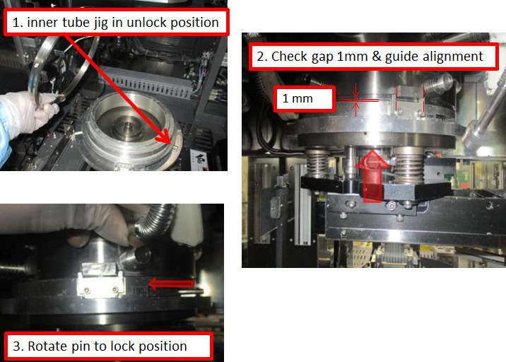
16. Move up manifold to chamber, lock in place. Then bring down lifter to P01 |  | 17. install L-120 injector |  | 18. Install inner tube, lock and bring down lifter

 |  | 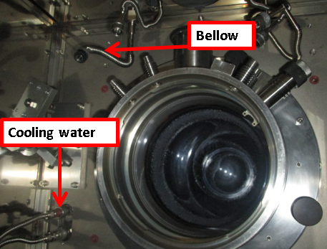 |  | 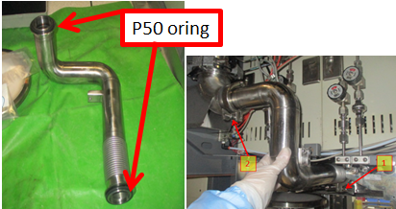
19. install L250 and L900 injector, use new P12 oring |  | 20. connect bellow and connect manifold cooling water, use P12 oring |  | 21. Assemble and install new pipe

Doc. #: 2017-CRP-002 rev.00 Page 2 of 4

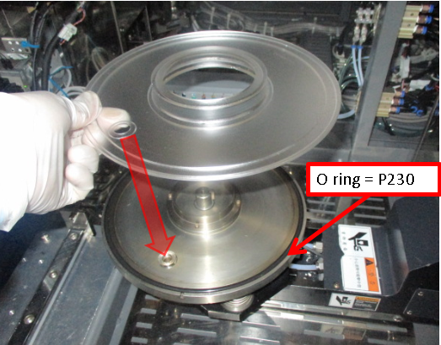 |  | 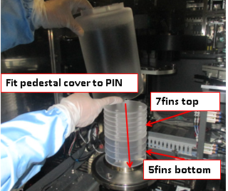 |  | 
22. Install dust tray |  | 23. Install pedestal (check if cover pin fits in place) |  | 24. Install boat

 |  |  |  | 
25. Put M06 in P01, put boat on top of pedestal and check alignment |  | 26. while M02 is in P02, Move M01 between P02 and P05, adjust if top of boat move |  | 27. Check chamber and boat gap, move boat at Ht.=1000 and rotate360deg

 |  | 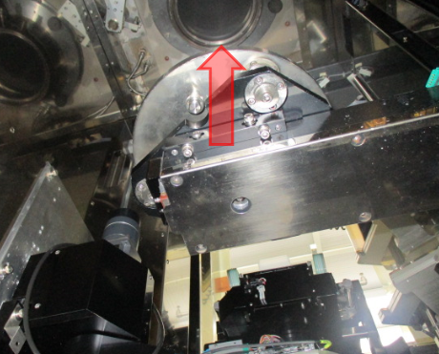 |  | 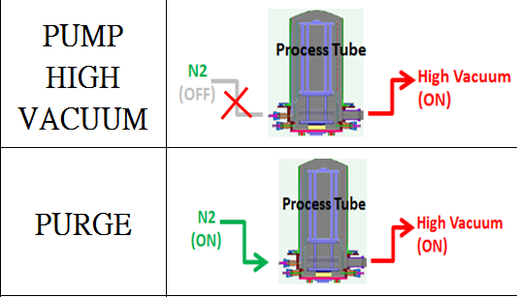
28. Put M02 in P01 to check/adjust boat lock |  | 29. Move Chamber lid up to close chamber |  | 30. pump vacuum, purge 20mins and do leak test <0.2 Torr/130sec For low temp (boat outside chamber)

 |  |  |  |   
31. Put boat M02 in P01 to do Transfer check. Load dummy wafer |  | 32. Check/adjust wafer position on boat, and fork gap between wafers |  | 33. Unload dummy wafer and cassette.

Doc. #: 2017-CRP-002 rev.00 Page 3 of 4

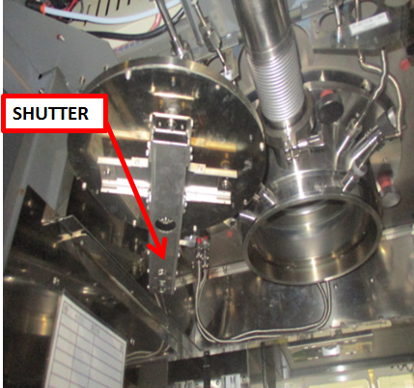 |  |  |  | 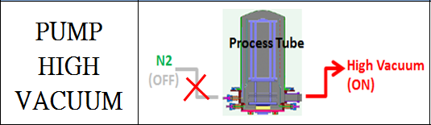  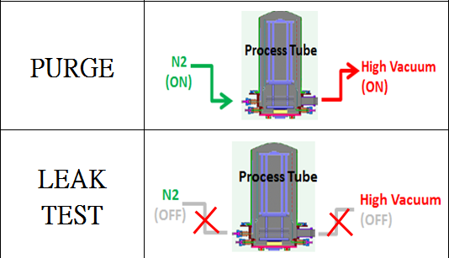
34. Install shutter & cover, check shutter movement. Move boat inside chamber. |  | 35. move boat inside chamber and pump vacuum to 0.00 Torr |  | 36. Open heater and purge 1hr, then leak test at High temperature P= <0.2 Torr in 130secs.(boat inside chamber)

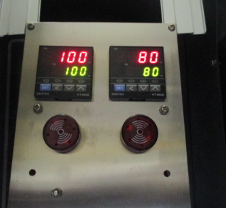 |  |  |  | EA TEST RUN
37. Check and adjust heater temperature settings at back of machine. |  | 38. Clean and Vacuum inside machine and Transfer robot area before close machine |  | 39. fill up machine log book PM OK and endorse to EA for test run

Doc. #: 2017-CRP-002 rev.00 Page 4 of 4

